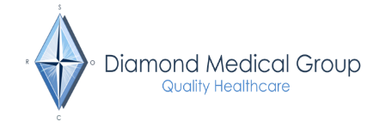

How to update your NHS App
If you are unable to access the NHS App following the practice merger, here are some instructions to follow. Please only follow these instructions if you still cannot use the NHS App.
The fastest way to resume online access is to remove the existing NHS App from your device. Once removed, then download the NHS App again and link it to Diamond Medical Group (B86019 – with a postcode of LS7 3DR. Then you will need to verify your identity.
If this does not work, we suggest deleting your account and creating a new account using the following steps:
1. Delete your account
Login to the NHS App on your mobile device > select More (in the top-right corner) > Account and Settings > Manage NHS Account > Login and Security Settings > Delete my NHS account (at the bottom of the page)
If you are unable to log in to the NHS App on your mobile device, please visit the website via the following link: https://account.login.nhs.uk/#/manage-nhs-login/delete
For security reasons, you will need to log in with your usual NHS login credentials. Once logged in, you will then be able to delete your account.
2. Create a new account via the NHS App
Once your login has been deleted, re-open the NHS App, select 'Continue with NHS login' and follow the on-screen instructions, registering using photo ID or by selecting 'How to prove who you are without sending a photo of your I.D.', then select 'Yes – I use online services'. On the following screen, select 'Yes – I have all 3 details' and follow the on-screen instructions to complete your registration.'
Please note, if you do not have photo ID, you will need to request 3 pieces of information from your surgery: your account ID, a “linkage key” (this may also be called a “passphrase”) and their Organisation Code 'B86019'
Once your online access is approved, you will then be able to re-connect to the surgery through the NHS App.

